It’s Time to Engage in a
“LEAP Initiative!”

Central Florida Presbytery offers congregations
the opportunity to purposely assess:

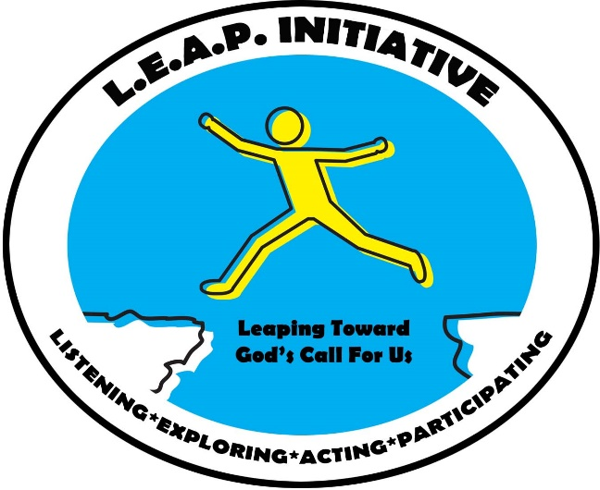
- WHO ARE WE?

- WHO ARE OUR NEIGHBORS?

- WHO IS GOD CALLING US TO BE?

- HOW WILL WE STEP INTO GOD’S FUTURE?
To schedule your
“LEAP Initiative”

Contact Cheryl Carson
(407) 422-7125 x. 204 or ccarson@cfpresbytery.org

Note: The congregation is asked to fill out a questionnaire that needs to be competed 6 weeks prior to the event.

There are other details that the congregation will be asked to provide, such as breaks, care for pre-school children, and assistance leading small groups. There is no charge for the Presbytery Leadership Team.

TWO DAYS

What: An interactive time of discovery, led by a team from the Presbytery. The team will provide leadership for all youth and adult gatherings and for the elementary-aged children’s activities.

When: Two days of the church’s
choosing

Where: Your church facilities
Who: Your whole congregation is
invited to participate,
including children and youth

