PATH Report, August 1st, 2023
Second Harvest Food Bank
Summer Break Spots: Partnered with 59 sites across Central Florida. The sites provide meals for school-aged children who are eligible for free/reduced lunch, and is funded by the state of Florida. Second Harvest partners with non-school locations such as community centers and summer camps run by non-profits. A total of 150,000 meals have been prepared by Mercy Kitchen and delivered daily. The school locations are not sponsored by Second Harvest.
Fly Beyond: Wawa has provided a new partnership to provide fresh fruits and vegetables
To at-risk students in 60 Central Florida schools with a $1,000,000 grant. The fruits and vegetables are sent home with students in Wawa-branded bags every Friday along with a QR code for families to access healthy recipes.
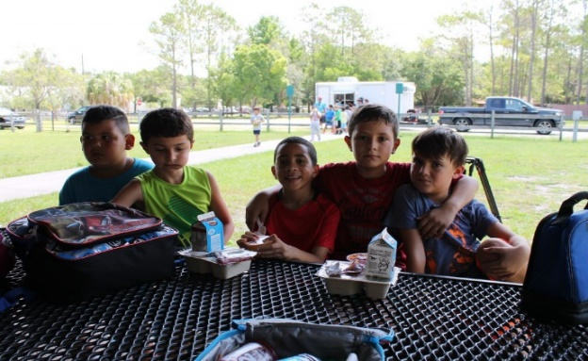
Medically-Tailored Meals Program:
As part of a partnership with the Food is Medicine Coalition, 2nd Harvest won a grant from DaVita Foundation to pilot a program focusing on providing medically approved meals for critically ill patients requiring special foods. Diseases such as renal disease, diabetes,
Coronary heart disease, and some cancers often require a special diet. Our chef, the patient’s medical team and a Registered Dietician work together to construct appropriate meals. It is expected that 20 patients can have meals delivered each week during the first year. Hopefully, the program can expand quickly after that. Similar programs have already been tested in Boston and New York.
Culinary Training Program:
The program just graduated its 50th class of students, for a total of 524 students since its inception. Job placement for above minimum wage positions is close to 100% with retention of 86% after one year. Many placements are in resorts, country clubs, and hotels, and offer growth and promotion opportunities.
Statistics: Fiscal year closed out June 30, 23
91 million pounds of groceries distributed
82 million meals
625 non-profit partners over 7 counties
1,200 qualifying households per week receive home delivery of food
Partnership programs include emergency food pantries, shelter programs, soup kitchens,
rehabilitation programs.
Madagascar
Mango Palace:
new water system being installed to irrigate 2 acres of tangerine groves
3rd building is under construction - when completed at the end of the year, Mango
Palace will begin selling trees
(New bldg. to be dedicated in February, 2024. All are invited to attend!)
Seminaries: Three Year Project:
Planting fast growing trees, utilizing 10 volunteers. They are digging wells, as water is
Currently being delivered in ox carts.
Work in Southern Madagascar:
Goal: to alleviate hunger
Dig wells, create water catchment systems, purchase oxen to carry water, serve meals to
school children, distributed 220 fruit trees to 13 parishes, starting nurseries of fast-
growing trees, train workers to graft trees.
PCUSA Funds:
Have been used to construct 2 new school buildings in the south with two more in
progress. The FJKM is sponsoring eight students from southern Madagascar to become
teachers.
Dan & Elizabeth in US: between late August and mid-January and will be available to speak at churches in person for the first time since the pandemic.

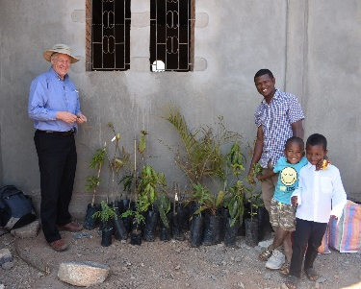

Society of Saint Andrew (SoSA)
Goal: is to cover the entire state
They have expanded gleaning territories and new farms. Thousands of pounds of food
have been distributed to new SoSA agencies and food banks.
The watermelon harvest has been especially bountiful. Mack Farms donated 11,000
pounds of edible but not saleable watermelons which SoSA rescued. PATH funding was
used to hire a box truck for transportation to be able to take advantage of the unusual
opportunity.
The harvest of mangos and avocados is next.
In partnership with the Florida Dept. of Agriculture, they are developing a program to
educate teachers about food waste and food insecurity.

The Alliance for International Reforestation – “AIR Guatemala”
Mission Teams:
AIR hosted 3 weeks of mission teams in June
Included 5 people from Central Florida presbytery, as well as Lawrenceville Presbyterian
and a PCUSA church from Mobile, AL
Planted 2,000 fast-growing trees
Built 9 fuel-efficient stoves
Painted AIR’s training center/mission hub
Renewed friendships with villagers & staff in San Pedro, Quiche and Chimaltenango
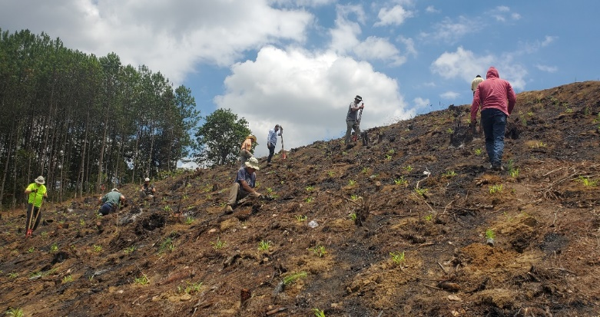
Reforesting a burned out area with a
Presbyterian team

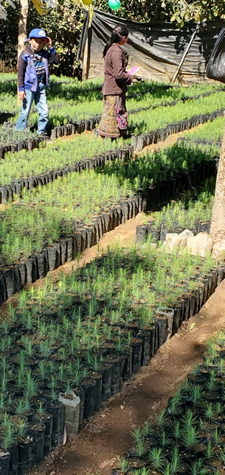
A terraced AIR tree nursery in Balanya
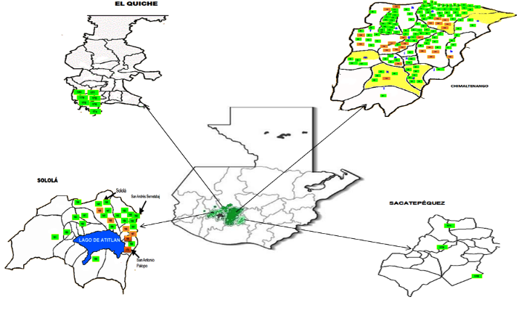
Groundbreaking for 2nd Mission Hub
The 2nd Mission Hub will be in Panajachel. Construction began in May. The work is now proceeding on schedule with proper reinforcement for earthquake tremors. God willing, the grand opening will occur in January 2024.

The list of communities seeking AIR’s training and tree nurseries has been growing, and we now have 5 full-time technicians there for a total of 10 in Guatemala and 1 full time/2 part time in Nicaragua. AIR is on track to produce 900,000 trees through the efforts of the farmers and technicians working in 70 rural communities. AIR provides training in nutrition,
fuel efficient stoves, and children’s scholarships. AIR thanks the dedication of the Central Florida Presbytery for its commitment to God’s important work.

