EL CENTRO PRESBYTERY OF CUBA
DATA BASE ON ITS CHURCHES
Background Information

Attached is a Data Base the Cuba Leadership Team has put together on the 13 churches in the El Centro (Central) Presbytery of Cuba as well as some background information on the Presbyterian Reformed Church in Cuba (PRCC). There are several things you should be aware of as you review the Data Base:

1) There are six pastors for the 13 churches. Each pastor has a primary church, yet they all oversee at least one other church. There are also 10 mission churches.

2) The membership at each of the churches is less than 100. However, as we have learned in our meetings with their Sessions, you must not only attend the church for at least one to two years before requesting to become a member but during that time you must have been active in the church. As a result, the number of people who participate in church activities and attend the worship service is greater than the actual number of members. Many of the churches have active youth and children's ministries.

3) Their pastors have provided input as to the need for relationships/partnerships of each of the 13 churches. As you will see, seven of our churches have either already entered into or are in the process of developing partnerships with eight of their churches. Their Council has said they genuinely hope we will take this into consideration as we look at which of their churches our churches might consider establishing a relationship with.

Keep in mind that a significant factor in our presbytery's decision to establish a partnership with this particularly presbytery, rather than either one of the other two presbyteries that serve Cuba, was that most presbyteries/congregations in the U.S. have partnerships with the Havana or Matanzas presbyteries. The only U.S. presbytery that currently has a partnership with El Centro Presbytery is the Presbytery of Baltimore. They have had a partnership with the Central Presbytery for 12 years and eight of their churches have partnerships with congregations in El Centro Presbytery. There are a few individual congregations in the U.S. that have partnerships with churches in the presbytery as well.

4) You are welcome to contact the churches which have partnerships with churches in El Centro Presbytery or the people who were on the November 2015 trip to Cuba if you would like more information about individual churches. We are giving you their email addresses but we are sure they would be happy to talk with you and discuss in further detail the churches at which they spent two to three days. Simply email them and ask for their phone numbers.
Cabaiguan
Partnership: First Pres., Vero Beach – Michael York michaelyork@firstpresvero.org
Carol Smoyer clsmoyer@bellsouth.net
Trip Participants: Laura Viau (First Apopka) – laurabviau@gmail.com
Edwin Silva (El Redentor) – edwinsilva7@gmail.com
Daniel & Lillian Berrios (South Lake) – dberrios6020@hotmail.com
Drew & Suzi Marshall (South Lake) – pastordrew@gmail.com

Caibarien
Partnership: North Lake Pres. – Becky Bros beckalaa1@gmail.com
Trip Participants: Laura Viau (First Apopka) – laurabviau@gmail.com
Ken Lasseter (Wekiva) – ken.lasseter@yahoo.com

Calabazar de Sagua
Trip Participants: Roy Bertolet (Christ Pres.) – rbertolet@gmail.com
Bill Harrington (Christ Pres.) – costabill@gmail.com
Carolyn Fitzwilliam (Port Orange) – cfitzwilliam@cfl.rr.com
Calvin & Lee Gittner (Port Orange) – gittner@aol.com
Gary Meredith (Port Orange) – garyjean@cfl.rr.com

Encrucijada
Partnership: First Kissimmee - Bucky & Maybelle Pratt wilburpratt1@gmail.com
Trip Participants: Ken Lasseter (Wekiva Pres.) ken.lasseter@yahoo.com

Iguara and Meneses
Partnership: Pineda Pres – Pat Zinn pezinn@bellsouth.net

Placetas
Trip Participants: The same people who were at Calabazar de Sagua

Remedios
Partnership: Wekiva Pres. – Ken Lasseter ken.lasseter@yahoo.com
Trip Participants: The same people who were at Cabaiguan from South Lake Pres.

Sagua la Grande
Trip Participants: Cindy Britt – lucinda51@yahoo.com

Sancti Spiritus
Partnership: GraceWay – Randy Simpson randysimpson111@gmail.com

Taguasco
Trip Participants: Cindy Britt – lucinda51@yahoo.com
Bucky & Maybelle Pratt – wilburpratt1@gmail.com

Please feel free to contact Ken Lasseter at 407-810-9123 or Randy Simpson at 352-516-4933 if you would like to discuss any of this.

CHURCHES IN CENTRAL PRESBYTERY OF CUBA
PRESBYTERIAN REFORMED CHURCH IN CUBA
September 30, 2016

The Synod of the Presbyterian Reformed Church in Cuba (PRCC) has approximately 4,000 members in 32 organized churches in three presbyteries: Havana, Matanzas, and El Centro. There are now some 90 church partnerships from 15 presbyteries around the U.S. The World Mission Cuba Mission Network is quite active with almost 100 people from the U.S. and Cuba attending their annual meetings.

The El Centro (Central) Presbytery of Cuba has 13 churches in the provinces of Villa Clara and Sancti Spiritus as well as eight missions, with one of them in a province some 200 miles away. There are six ordained pastors and five lay pastors.

All of this is quite a change from what existed in the first 30 years (1960 – 1989) of Fidel Castro’s Communist government.

History of the Presbyterian Church in Cuba
The connection between U.S. and Cuban Presbyterians began in 1890 with the work of a Cuban layman and former Baptist lay preacher, Evaristo Collazo, and his wife, Magdalena. They started a day school in their home in Havana, which included Bible studies. Collazo wrote to the Board of Foreign Missions of the Southern Presbyterian Church asking for assistance. The PCUS sent Rev. Anthony Graybill to Havana. He baptized 40 adults, organized a congregation, ordained elders, and ordained Collazo to the ministry and installed him as pastor.

By 1904, there were seven Presbyterian churches in Havana. They were organized into a presbytery and became part of the Synod of New Jersey. Between 1904 and 1960, the Presbyterian Church in Cuba continued to grow with strong support from the U.S. Presbyterian Church through its Board of National Missions. By 1959, the Presbytery of Cuba had 4,300 members in 34 congregations with 46 ministers. Further, there were 1,400 students in a number of Presbyterian schools, primarily located in the provinces of Villa Clara and Sancti Spiritus (the location of the Central Presbytery of Cuba).

In 1961, two years after the revolution that brought Castro to power, the U.S. broke diplomatic relations with Cuba and imposed an embargo. Castro declared Communism as the form of government and confiscated the schools and clinics of the churches. Subsequently the Presbyterian Church in Cuba rapidly declined. The U.S. Presbyterian Church was unable to support and communicate with its Cuban brothers and sisters. Many Cuban pastors and lay leaders left the country. By 1979, membership in the Cuban Presbyterian Church had dropped to 1,289. In fact, it was women who sustained the church as men left the church for fear of losing their jobs. Children were even asked at school on Monday if they had attended church over the weekend. If they said yes, teachers were required to report it to the government. This is not to suggest that being a Christian in Cuba at this time was dangerous, though at times it was, but more than anything it was a great and difficult disadvantage.

In 1985, representatives of the PC(USA) mission agencies were permitted to travel to Cuba to meet with the PRCC. A Joint Mission Agreement, approved by both denominations in 1986, among other things approved the formation of partnership between presbyteries of the two churches.

In 1990, 75 Protestant church leaders met with Castro to discuss church-state relations. After the meetings, Castro stated in a broadcast over Cuban national TV that religious groups were providing important support for the Cuban people in a time of great stress and should be respected. Laws were subsequently changed to permit religious believers to become members of the Communist party and that Cuba was no longer to be defined as an atheist state. Most analysts strongly believed that the disintegration of the Soviet bloc, which resulted in immediate and catastrophic economic collapse in Cuba, was a significant factor in Castro’s decision.

As noted, there are now some 90 church partnerships from 15 presbyteries around the U.S. Our partnership with Cuban Presbyterians is broad and deep.

CABAIGUAN
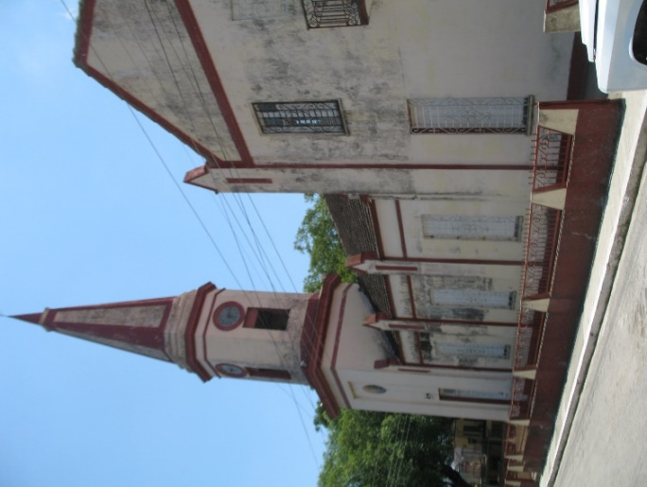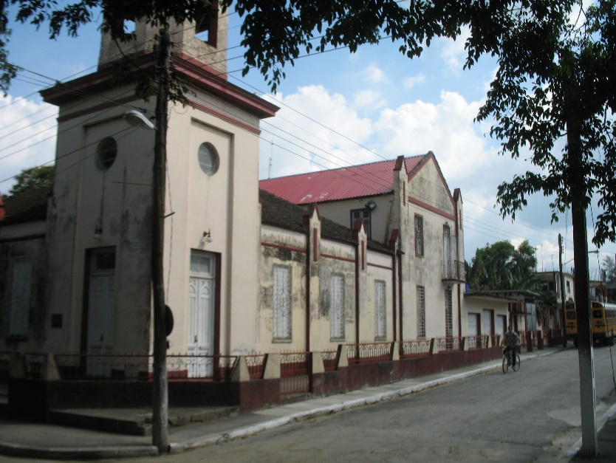

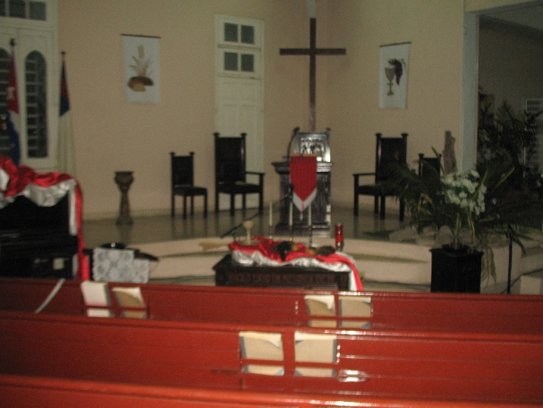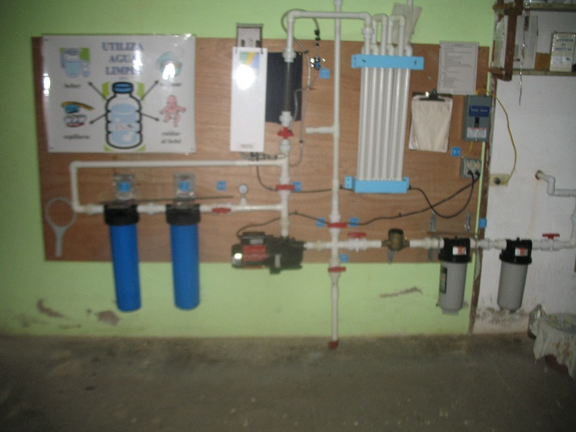

City: Located in province of Sancti Spiritus with a population of 30,000

Economy: Oil refinery and related businesses and agriculture (tobacco, rice, sugar cane, fruits)

Pastor: Marlon Irrarragorri; this is his primary church. He is Moderator of the presbytery.
He is 33; married; two daughters, ages 6 and 2. Speaks English fairly well.

Church: Organized in 1907; Sanctuary built in 1924. Membership: ~ 80; Average Age: 40-60

Church Projects/Activities:
- Living Waters for the World water purification system installed November 2014
- Laundry project: two days a week, benefits ~50 people (mostly elderly and infirmed, many from a local nursing home). Started 17 years ago, first one in the presbytery.
- Breakfast project: one day a week church provides breakfast; benefits ~50 people
- Craft and art therapy for women: women sew, make cards and other crafts.
- Youth Group (Ecologia Planetaria): 10-15 youth. Meets monthly at various locations of environmental interest. Will include devotional and info on the location where meeting.
- Children under 15 years of age are provided a lunch and activity once a month.
- Prayer and Bible studies take place in six homes once a week, usually led by an elder or a deacon.
- AA meets at the church
- Mission Sites: Paraiso Obrero (2) – Worship service and Sunday school. Wednesday evening mission work. A LWW water purification system was installed in May 2016. Banao – Worship service on Tuesday
- First Saturday of month: men, women, and children’s groups meet and do varied activities such as dance, tai chi, etc.
- Guitar lessons

Church Needs/Dreams:
- Pastor’s residence: Significant renovations are needed to his home. Baltimore Presbytery is providing the funds to repair just the roof/ceiling.
- Create a project for people with disabilities
- Create a lunch project for the elderly several days a week
- Training for Sunday school teachers, to include training DVDs that can be purchased in Cuba.
- More facilities for classrooms
- Create a laundry project at Paraiso Obrero mission.

Partnerships /Friendships:
- Ashland Presbyterian (Baltimore Presbytery). Primarily a friendship with a few members
of the church though it is strengthening.
- Light Street Presbyterian (Baltimore Presbytery). Partnership just with the Paraiso Obrero
mission. Strong partnership.
- First Presbyterian Church of Vero Beach (Central Florida Presbytery) began in 2016.
A trip is planned for the Spring of 2017.

Church Strengths: The pastor and elders believe it is the unity of the church with people of all ages. Also, the church has many leaders with some 15 people who can teach as well as preach if asked.

Overnight Accommodations: Can accommodate 12 people. Two rooms with two bunk beds in each room with private bathroom. Another room with two bunk beds and a bathroom down the hall. Bathrooms are nice with hot water.
CAIBARIEN
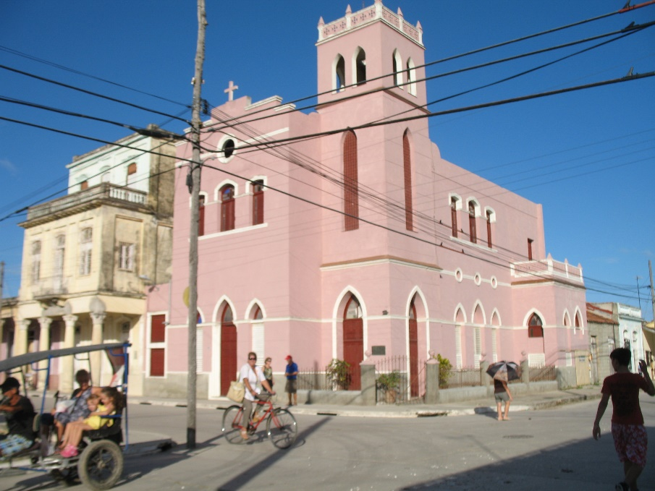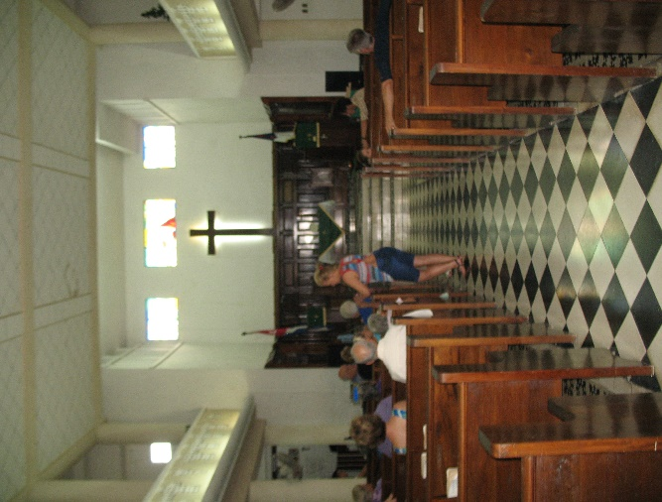

City: Located in province of Villa Clara on the northern coast with a population of 38,000.

Economy: Sustained by fishing and tourism. At one time it was a busy shipping port with several sugar mills. Those have all been shut down, severely damaging the city’s economic base. The heart of the tourism takes place in the archipelago of islands (Los Cayos) about 20 miles NE of the city. Many of the Cubans who work there live in Caibarien and travel there by bus.

Pastor: Edelberto Valdes; this is his primary church. He is the Executive Secretary of the presbytery.
He speaks English well.

Church: Organized in 1902. Membership: ~75, with many youth.

Church Projects/Activities:
- On Sundays, Sunday School is in the morning and the worship service is that night. However, a short sermon is preached in the morning as well before they separate for Sunday school classes.
- On Tuesdays there are prayer meetings at the church. There are prayer meetings in homes at other times.
- On Wednesdays there is a Bible study in the morning
- Lunch & Dinner: Feed 40 people, 3 times a week (M, W, F). The elderly take their evening meal with them after eating lunch at the church. A church in Germany funds this.
- English classes: 20 to 25 people, four times a week
- Sewing shop
- AA meets at the church
- There are meetings in homes on Thursdays with communion served twice a month
- Mission Site: Camaguey (3), which is ~180 miles east of the city. Twenty people meet in a home and it is led by an elder. There is worship on Sundays, a Tuesday prayer meeting, and a Bible study on Thursdays. Edelberto travels there ~ once a quarter. It is expensive to support.
- There is a prayer house, primarily for children, where they do crafts.

Church Needs/Dreams:
- Transportation: They rent a motorcycle cart on Sundays to pick up children and the elderly for Sunday school in the morning and church at night. The rental is $600/year. To purchase a used one would cost $10,000.
- The Session dreams of painting the outside of the building and getting music in the bell tower. (Virtually all of the churches need to be pressure washed and painted.)
- They cannot install a Living Waters system as they receive water from the city only twice a week.
- The roof must be repaired every two years due to salt damage.
- Create a laundry project

Partnerships/Partnerships):
- There is a partnership with a German church that has financially supported the feeding
program for 20 years. They do not visit.
- North Lake Presbyterian Church (Central Florida Presbytery) began a three year partnership
in 2016. North Lake will be visiting in January 2017
- Partnership with Rio Rancho in New Mexico (Santa Fe Presbytery). Strong relationship.
A large group visited in 2016 and another visit is planned for 2017.
It will include a youth exchange.
Church Strengths: They have a very active youth program. Two of us met with about 15 youth on Sunday morning and they asked many questions. There are two other churches in town. Edelberto has a close working relationship with the nuns at the Catholic church. The Baptist church is not interested in working together. The North Lake Mission team also met with the youth during their visit in Nov. 2015.
North Lake hosted Mercedes in the spring of 2016 and sent back craft supplies, coloring books, and art supplies.

Overnight Accommodations: They can provide housing for ~16 people in three rooms. Bathroom is down the hall. To reach the rooms requires climbing a narrow, steep staircase. There are 2 bathrooms. North Lake provided funds to fix the plumbing in the bathrooms. They also purchased new mattresses for the beds. The food is very good.

CALABAZAR DE SAGUA
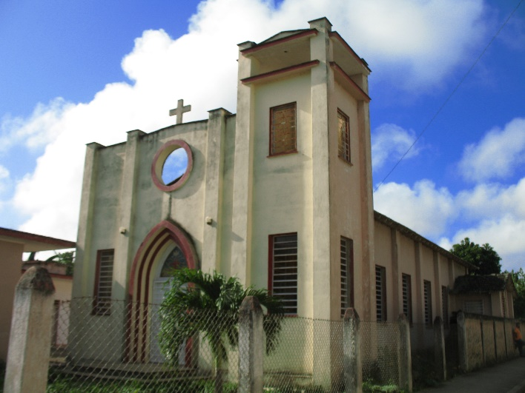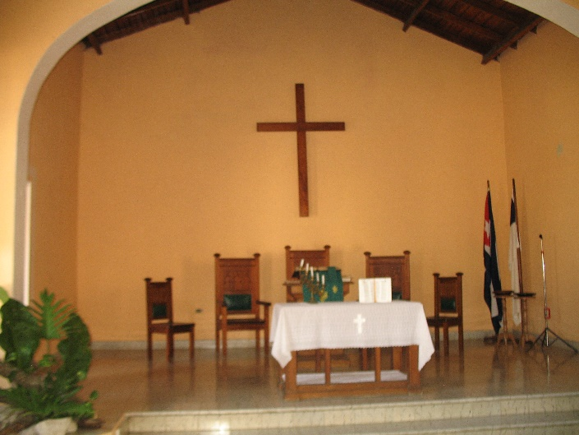

City: Located in province of Villa Clara in central part of the country with a population of less
than 10,000.

Economy: Sustained by manufacture of soda and rum; agriculture (rice and sugar cane);
large sugar cane processing plant; livestock.

Pastor: Marielys Cabrera Leal; this is not her primary church. Lay candidateto the seminary, Reile Marrero, assists the pastor.
Speaks limited English.

Church: Organized in 1941. Membership is ~36. Sanctuary was built in ~1985.
Has additional wing that has a full kitchen, dining area, and two bedrooms.

Church Projects/Activities:
- Sunday: Worship and Sunday school
- Tuesday: Encounter with the Bible (Bible study)
- Wednesday: Meeting of seniors of the Church with physicians
- Thursday: Visitation for prayer (in small groups)
- Saturday: Youth group meetings. Very active youth group
- Women’s group: Makes arts and crafts, which sell locally for funds to use for elderly in need in town. Led by two women who are responsible for many activities in the church.
- Dorcas Project (laundry)
- AA meets at the church

Church Needs/Dreams:
- Often have difficulty with water system
- Build a kitchen and dining area
- Create a breakfast project to feed the elderly

Partnerships/Friendships:
- First Presbyterian of Howard County (Baltimore Presbytery). Strong and healthy relationship.

Church Strengths:
- Strong women’s group with committed leadership (though this was under the former
female pastor).
- Active youth program with a focus on music.

Overnight Accommodations: Large dormitory with eight bunk beds. One private BR for one couple. One bathroom. This wing is being remodeled. Full kitchen and dining area. Good meals.

CAMAJUANI

City: Located in province of Villa Clara with a population of ~ 20,000

Economy: Primarily agriculture (sugar cane and tobacco)

Pastor: Marielys Cabrera Leal; this is her primary church.

Church: Organized in 1912. Membership: ~70 with many children and youth.
New fellowship hall recently built by German church.

Church Projects/Activities:
- Sunday morning worship, includes 4 Sunday School classes
- Monday-Friday: Breakfast for 35 needy people
- Tuesday morning: Prayer service
- Wednesday: Laundry program
- Wednesday night: Leadership training
- Thursday-Friday: Offsite prayer group
- Mon, Wed & Fri: Exercise for the elderly
- Saturday: Children’s activity with lunch
- Tues & Fri: AA meetings
- Mission project at Muelas Quietas with various activities for 15 adults and 10 children
- Four elders comprise the Session
- Large garden on property used for feeding projects

Church Needs/Dreams:
- Support group program for people with terminal diseases; support programs for their families
- as well.
- Restart sewing workshop.
- Repainting multi-purpose room using a special paint to kill the mold on the wall
- It appears most of their financial needs are being met

Partnerships /Friendships:
- Pawleys Island Presbyterian, Pawleys Island, SC. The person leading this partnership has
moved to and ECO church.
- Eagle Creek Presbyterian, Eagle Creek, OR
- Northeast District of Germany. Though visit every two years, not a strong partnership.

Church Strengths: The previous pastor built many relationships, and it shows. Church is well organized.
- Have computer system for teenagers to use
- Have computer in worship service for visuals and music
- Much outreach to the community

Overnight Accommodations: Three well-lit clean rooms with bunk beds, tile floors and a private bathroom
that was new and modern. Still in the process of furnishing it. Sleeps approximately 12 people.

ENCRUCIJADA
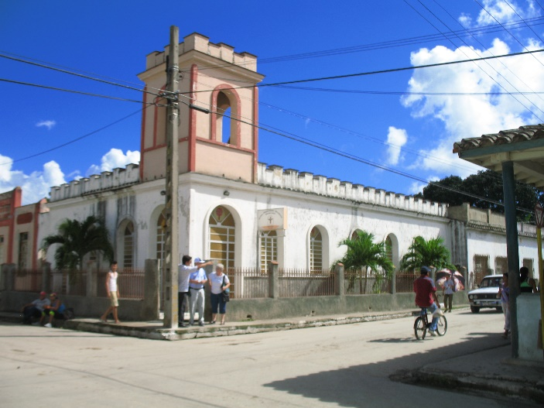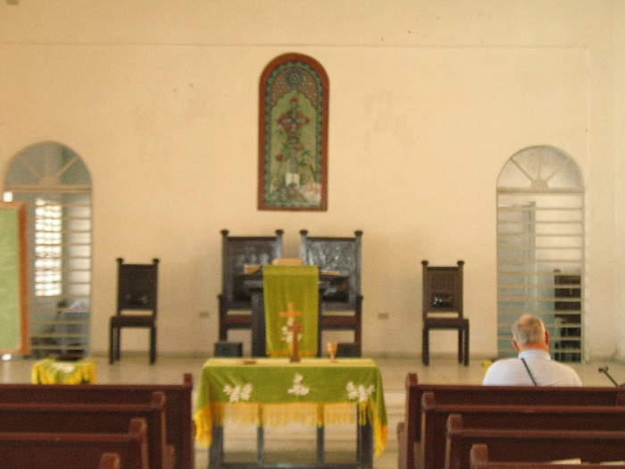

City: Located in province of Villa Clara, near the northern coast with a population of ~ 34,000.

Economy: Sustained by sugar mills, agriculture (rice, sugarcane, fruits), and a cigar factory. Has
a hospital.

Pastor: Dalia Valdes Rodriguez, though only limited time at the church. No lay pastor to assist. A husband and wife, who serve on Session, have been keeping the food and laundry programs going for
many years.

Church: First organized in 1926-29 with help from the church in Remedios by Pastor Ferrell de Jesus Gomez. The church building was constructed of bricks in 1929. The land was given by Joaquin Noriella. In 1940 a school was added; in 1950 the pastor’s house was built. From 1940-50 a clinic was attached to the church. From 2005-2009 a Presbyterian Church in Hickory, N.C. helped with the renovation of the sanctuary. This church is no longer involved. Quality of water in the area is good according to church members. Membership is ~ 25. (Just prior to the revolution in 1959, the church had 200 members.)

Church Projects/Activities:
- On Sunday there is Sunday school for adults and children. There are two teachers.
- On Tuesday they visit families who cannot come to church with prayer and Bible study.
- On Wednesday there is Bible Study for all adults in the evening.
- The worship service is Saturday night at which communion is served as well.
- On Tuesday and Friday there is lunch for 20 people. A church in Germany funds this and
each year it must be approved for $780/yr. The church would feed more people if funds
were available.
- Twice a week laundry is washed for elderly and infirmed. There are no funds pledged for
this project. The church has one washing machine.

Church Needs/Dreams:
- Projects to bring youth into the church through recreation: TV and Videos. Videos are
very expensive in Cuba.
- Money for 2-3 Day Youth retreats to study Bible or other subjects of interest. Currently
have 5 Youth ages 18-30. The Presbyterian camp currently has no funds to send children to it.
- Expand the laundry project. Another washing machine would cost about $200.00.
- The church is currently finishing bathrooms for women and men. There is a roofless
Structure across the patio from the bathrooms that is capable of being rebuilt into
dormitories…not aware of any funding for this.
- Tables and chairs are needed. They currently use makeshift tables and chairs.

Partnerships/Friendships:
- Has a new partnership with First Presbyterian Kissimmee (Central Florida Presbytery) which
has sent some funds for a freezer to help in their feeding program.
- Covenant Presbyterian Church (Baltimore Presbytery). A new partnership. Slowly developing.

Church Strengths: There is a lot of musical talent at this church as with many others. There were
about 70 people attending a musical program on a Sunday night while the December 2014 mission
team was there.

Overnight Accommodations: The attached buildings of this church are in need of renovation. At this time the overnight facilities (especially the only bathroom) are inadequate. The mission team that visited in Nov. 2015 stayed at the church in Calabazar de Sagua, about 5 km away.

IGUARA
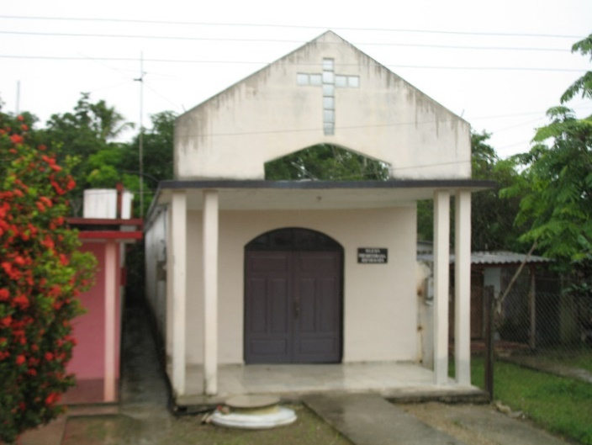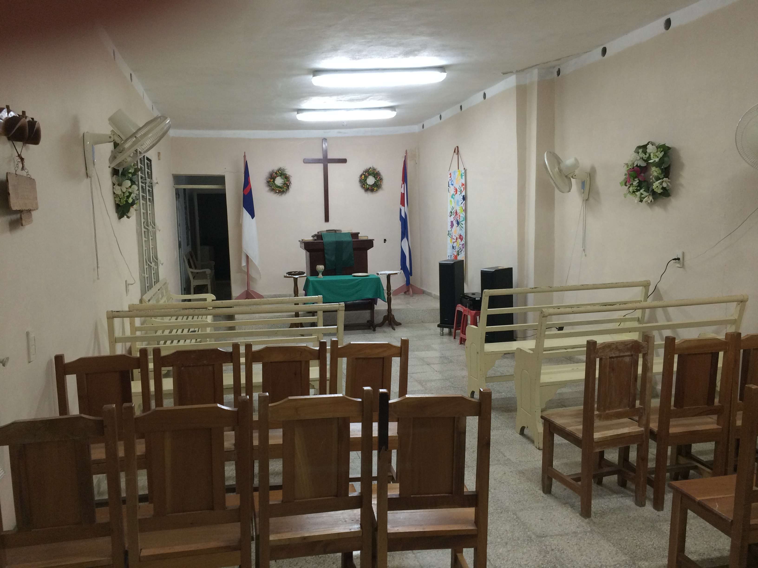

City: Located in central part of the province of Sancti Spiritus with a population of ~4,000 and located about 4 km from Meneses. Rural area. Iguana has a primary and secondary (middle school); students have to travel to Meneses for Pre (pre-university).

Economy: Sustained by agriculture: raising cattle (beef for tourists, dairy) cultivation of corn and beans; cheese and butter factory.

Pastor: Marlon Irrarragorri; not his primary church. He comes about once a month and serves communion. He is assisted by lay worker Lester Manso, who has completed 3 years of seminary and hopes to be ordained after exams in June 2017. Lester is a charismatic and energetic man in his late thirties. He spends a good deal of time visiting the sick in homes and demonstrates a lot of heart for the people. He has attracted a lot of youth and children to the church. He does not speak English.

Church: Organized in 1991, although people met in a home beginning in 1949. Sanctuary built in 1999.
Membership ~24, though many attend who are not members. Church is growing. Very active youth
and children’s programs.

Church Projects/Activities:
- Sunday: Sunday school
- Wednesday: Bible study
- Thursday and Friday: House of Prayer
- Saturday night: Worship service
- Children’s educational program
- Large Christmas pageant with over 20 children
- Sewing workshop
- Feeding program (Lunch for about 20 seniors) through bread for the world. (This project might not be active at this time.)
- There is a laundry program for the elderly.
- They have a Sunday School program for children with disabilities.

Church Needs/Dreams:
- Expand the lunch program
- Create a music workshop
- Build small wall with side benches around front porch of the church, to provide a place for children
- Start a water project

Partnerships/Friendships:
- Faith Presbyterian Church (Baltimore Presbytery). Strong partnership.
- Has a new partnership with Pineda Presbyterian Church, (Central Florida Presbytery).

Church Strengths:
- The lay leader is well liked and a tremendous asset to the church. He has energized the youth and children’s programs and the church is growing.
- Lots of involvement of members in worship, including singing and playing guitar. One teenage girl exhibits leadership among youth and in worship. There are several active elders. Lester is building the leadership so that worship and activities continue when he is absent (for example trips to the seminary).
- Youth are starting to reach out to homebound members by visiting them
- Caring church community – Youth make an effort to include two children with medical disabilities when possible for them to participate
- This would be a good church to partner with if one of our churches is looking for a small but vibrant church in a rural area.

Overnight Accommodations: None at the church. However, a small group can stay across the street at the pastor’s house and up a steep flight of stairs. A bedroom can house 2 or 3 women and another 1 or 2 men can share with Lester in a second room. There is a good bathroom with shower (cold water). One of the women of the church prepares meals. Sheets were provided, but visitors should bring towels (and sheets if more than 2 people are staying).

MENESES
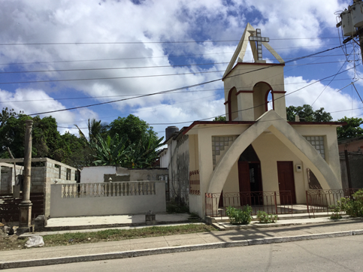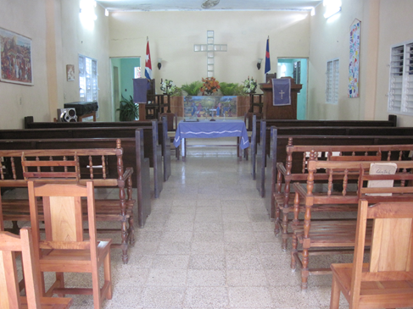

City: Located in the province of Sancti Spiritus with a population of ~ 11,000 and located about
4 km from Iguara. Meneses has a very large primary school, a secondary (middle school) and a Pre (pre university high school).

Economy: Agriculture and some small factories (clothing, processing wheat, also a small bakery and sweets/candy factory).

Pastor: Edelberto Valdes; not his primary church. The church is currently led by Clerk of Session, Mercedes (Mercy) Rodriguez Morales and assisted by other ruling elders. The session is active.

Church: Organized in 1926; sanctuary built in 2008. Membership ~ 24. Some people who left the church after the departure of the former pastor are returning because of the pastoral care and outreach of Mercy and the other members.

Church Projects/Activities:
- Sunday: Sunday school
- Monday: sewing with women
- Tuesday and Thursday: sewing with girls
- Wednesday: Bible study
- Thursday and Friday: Prayer meetings
- Saturday night: Worship service
- Laundry project: Do laundry for those in need, though limited by available machines. Working with their partner, Faith Presbyterian, to expand this program.
- Blood pressure and diabetes testing for elderly twice a month
- Teach young girls sewing as have 3 treadle sewing machines. Also teach them knitting and crochet. They sell their crafts to fund the project and also give some to needy.
- Feed 20 seniors, twice a month (through Bread for the World)

Church Needs/Dreams:
- Their major dream is to expand the laundry mission as there is a great need for this service in the area. Faith Presbyterian Church helped them purchase an adjoining lot and hope to add a laundry annex. They would like to extend the roof in that outdoor area.
- To have a house for a pastor
- To have Sunday school teachers
- Finish a cinderblock wall around the church property, to make it more secure
- Expand the feeding program
- Continue to expand the sewing project for women and children. Fabric, thread, and yarn are difficult to obtain and donations would be greatly appreciated.
- To restart the project of blood pressure and diabetes testing for the elderly

Partnerships/Friendships:
- Faith Presbyterian Church (Baltimore Presbytery).
- Has a new partnership with Pineda Presbyterian Church, (Central Florida Presbytery).

Church Strengths: A Session of two is quite active and will be expanding to 4 members in late 2016. The Session has a vision of expanding their outreach but do not have the funds to do so. The church is especially focused on serving the community through feeding projects, laundry projects, and teaching sewing. The sewing project is especially well received. Mercy would like to expand it beyond aprons to make clothing and blankets.

Overnight Accommodations: The church has 2 beds in a curtained-off area of the fellowship hall, and a small bathroom with shower (cold water). The people of the church really appreciate visitors staying overnight, but first time visitors would probably prefer to stay at Iguara (4 km away) and make day trips. Day trips would be possible from Cabaiguan or Sancti Spiritus, but they are both at least an hours drive, which makes transportation more challenging.

PLACETAS

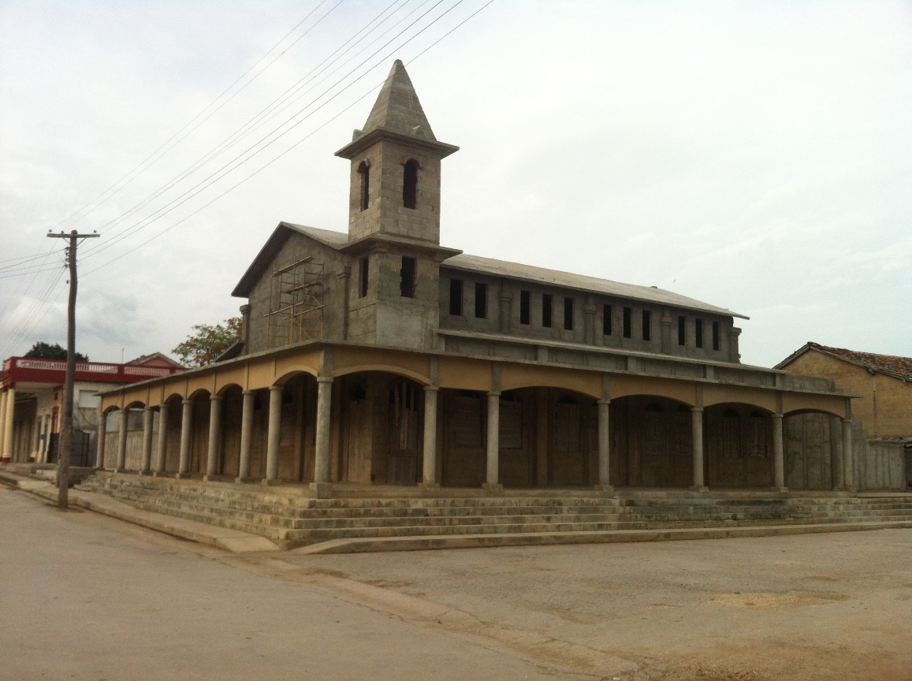

City: Located in central part of province of Villa Clara. Population of ~ 75,000.

Economy: There is a tobacco company. The area had three sugar production factories which have been closed, effecting the local economy. The area also has other agriculture: rice, sugarcane, and fruits. A sizable population of immigrants provides income through remittances. There is also many small businesses. Despite all of this, unemployment in the area is very high.

Pastor: Jesus Rodriguez; not his primary church; assisted by Lianne Navaro, a candidate to be a pastor.

Church: Organized in 1908. The old sanctuary was condemned and demolished in 2011. Congregation meets in the house across the street. A new sanctuary was started with assistance of Baltimore Presbytery. They are still raising funds to finish the sanctuary.
Membership ~ 70; youth group of ~30.

Church Projects/Activities:
- Sunday: Worship service and five Sunday School classes
- Tuesday: Prayer service
- Wednesday: Mission project at El Copey (2) includes a worship service
- Friday: House of Prayer (ecumenical: Methodist, Catholic, and Pentecostal)
- Laundry project: Benefits about 30 people, twice a week.
- Lunch project: For past eight years feed lunch to 35 people in need, twice a week.
- Sewing workshop for ladies in the community.
- Distributes OTC medications and colostomy bags when available.

Church Needs/Dreams:
- Complete construction of the sanctuary
- Expand the feeding program

Partnerships/Friendships
- Relationship with Pilgrimage Ministries in Delaware through John Potter. Strong relationship.
- Partnership being developed with Port Orange Presbyterian (Central Florida Presbytery).

Church Strengths: Unknown

Overnight Accommodations: Two bedrooms with 2 or 3 bunk beds in each room.

REMEDIOS

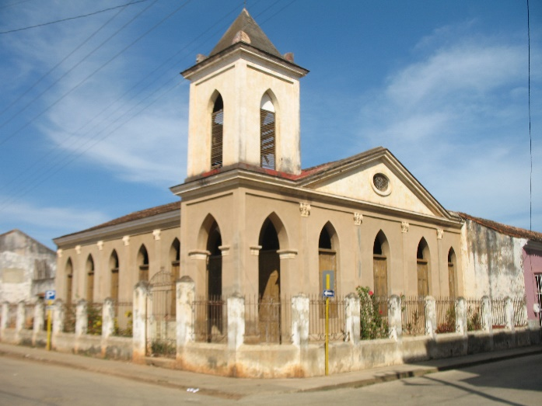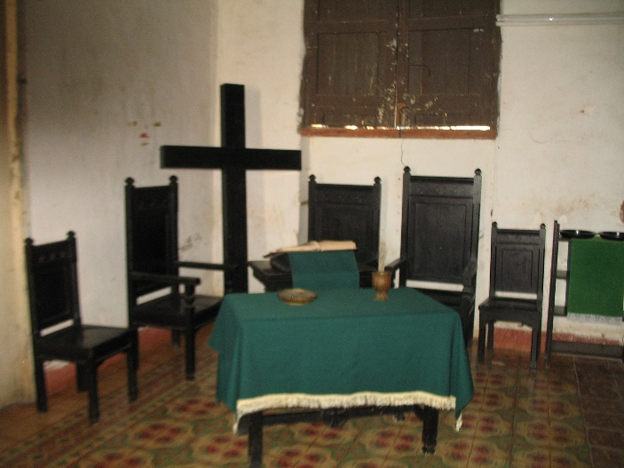

City: Located in province of Villa Clara near the northern coast with a population of 46,000. One of the eighth Spanish settlement in Cuba. There is a lovely central square and a beautiful Catholic church.

Economy: Sustained by agriculture (rice, sugarcane, fruits) and tourism.

Pastor: Jesus Rodriguez. Assisted by ruling elder Olga Comas.

Church: The church is named “Evaristo Collazo” after the first Presbyterian minister to preach (in a local theater) in 1890. Organized in 1902 by missionary John Walton, who came to Remedios as an evangelical Presbyterian minister. Church structure was originally built in 1911 but is undergoing a total restoration with the help of Myers Park Presbyterian Church in Charlotte, NC. Membership: ~40.

Church Projects/Activities:
- Wednesday night Bible Study
- Laundry project for the elderly once a week on Wednesday.
- Program for the handicapped youth, called “Dreams and Hopes Project”. This project involves 13
handicapped youth combined with 27 children who do not have handicaps to help provide a
more normal situation for the handicapped. December 2014 Mission Team observed an activity
where these youth were taken to a small farm outside the town where there were animals,
plants, and trees and a place for children to play. Environmental stewardship was a theme.
This program is expensive as it sometimes requires a large number of art supplies for their
projects.
- Daily Bread feeding program is provided at noon on Tuesday, Wednesday and Thursday.
- Crafts project

Church Needs/Dreams:
- Sunday School art materials: Large pieces of paper, pens, paint, Crayola crayons, felt pens
(different colors), scissors, fabric, knitting yarn
- Complete construction of the sanctuary

Partnerships/Friendships:
- Myers Park Presbyterian Church (Charlotte, NC). Strong Partnership.
- Church of Korea, new roof in November 2015
- Wekiva Presbyterian, Longwood, FL (Central Fla. Presbytery) will begin a partnership in 2017.
- German church: weak partnership.

Church Strengths:
There is respect for all members and great team work. The church creates many things by hand. Youth also lead the church during Sunday church service, Quality of water in the area is good according to church members.

Overnight Accommodations: There are 5 bedrooms, each with a private bathroom, all newly completed. Bedrooms have air conditioning and hot water. There are accommodations for 18 people.

SAGUA LA GRANDE
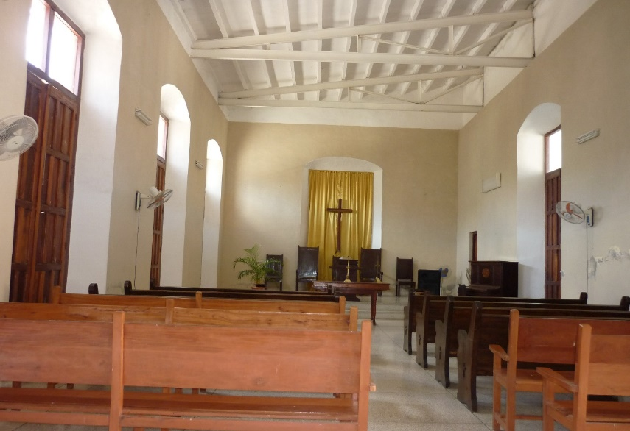

City: Located on the northern coast in the province of Villa Clara. Population ~ 56,000.

Economy: Sustained by spark plug and chemical factories as well as a harbor nearby. Some agriculture in area. Also have cattle farming and fishing. There is a medical university. Nonetheless, city suffers from high unemployment.

Pastor: Dalia Valdes; this is her primary church. She became the pastor in January 2015 as previous pastor accepted a call to a church in Havana Presbytery. Speaks limited English.

Church: Organized in 1914. New sanctuary built in 2006 with financial assistance from Santa Fe Presbyterian Church. Membership ~ 21. Many others attend who are not members.

Church Projects/Activities:
- Sunday: Worship and Sunday School
- Tuesday: Classes for mew members; pastoral counseling
- Wednesday: Bible study
- Thursday and Friday: Pastoral counseling
- Saturday: Activities for children and youth
- Breakfast project: Serve breakfast to 15 people, twice a week
- Music School: Previously consisted of a member of the church who taught piano lessons to children. Currrently inactive due ato poor condition of the church’s piano.

Church Needs/Dreams:
- Their primary goal is to become a neighborhood church and draw in youth.
- Repair the washing machine and restart the laundry project
- Replace the piano and begin offering piano lessons again.

Partnerships/Friendships:
- First Presbyterian Church of Santa Fe, NM
- Hunting Ridge Presbyterian Church (Baltimore Presbytery)

Church Strengths: Their music school. The pastor visits shut-ins regularly. The church is most proud of its music program. The piano player has taught many people to play, but termites have destroyed the piano and they are trying to get another one.

Overnight Accommodations: One bedroom with two single beds and one bedroom three single beds. There is a men’s and womens’s bathroom, both with hot water.

SANCTI SPIRITUS
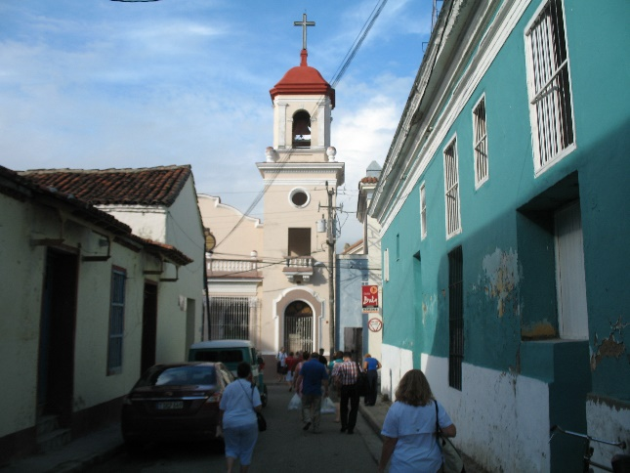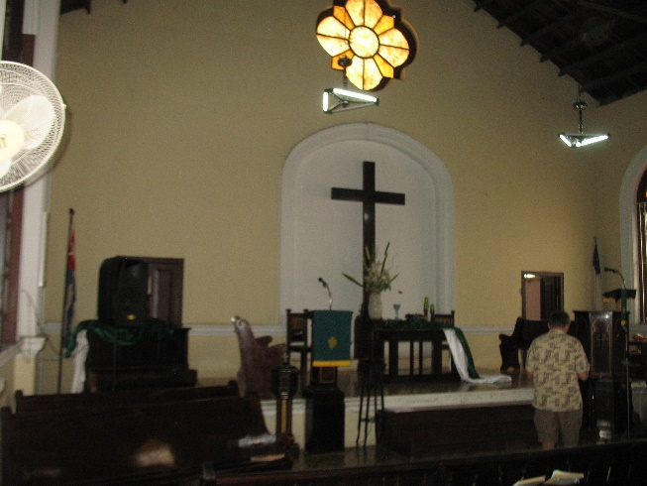
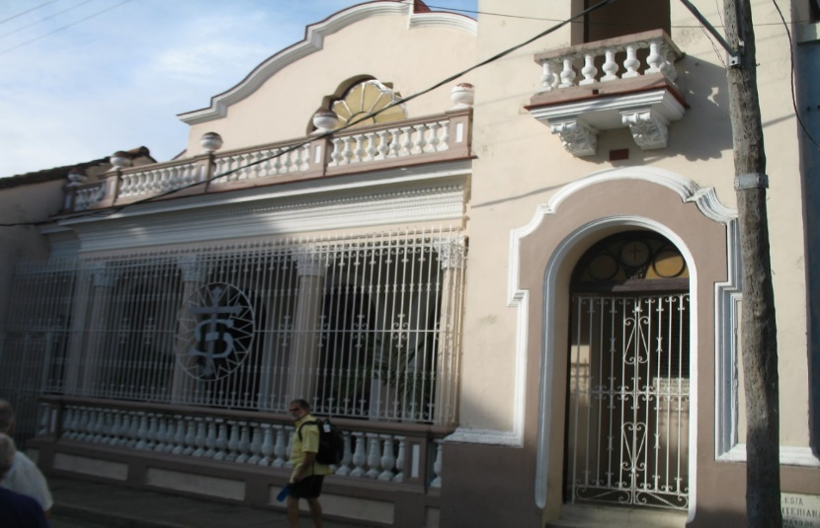

City: Located in province of Sancti Spiritus with a population of 115,000; beautiful colonial city.

Economy: Sustained by agriculture (livestock, tobacco, sugar cane). Highly regarded medical university.

Pastor: Liudmila Hernandez; this is her primary church. She is head of the International and Ecumenical Affairs Committee for the presbytery. She is 27; single; ordained Nov. 2014. Seems greatly loved by her congregation. She interned here for a year in 2012. Speaks English fairly well.

Church: Organized in 1902. Membership ~90 and growing, with a number of children and youth.

Church Projects/Activities:
- On Sundays, have 6 Sunday School classes; average 90 in worship.
- Living Waters for the World water purification system installed July 2012. This has had a profound impact on the community. Provide some 3,000 liters of water per day, M-F to about 150 people. They accept contributions, with the goal of the system becoming self-sustaining.
- Active music ministry
- Lunch in cooked for 40 people every day who are disabled and/or elderly and thus homebound. Meal is picked up.
- Active youth program. They will regularly come together to visit elderly members who are homebound as well as providing laundry service to them.
- Sewing and knitting/crocheting mission: Mend and make clothes for the elderly/shut-ins. They sell some clothes that they make so that they can purchase more materials
- Ecumenical Center: Can provide accommodations (beds) for up to 50 people for workshops, courses, etc. Including food service. This raises money for the church’s various projects.
- AA meets at the church
- Mission site: Toyos (2): A very poor barrio, about 10 minute drive. Have a small chapel for services and a music ministry for 35 local children and youth, twice a week. A church in Switzerland provided money for musical instruments. They are also taught to read music. Have a Bible study on Thursday and a Bible School on Sunday. They also have a sewing and knitting/crocheting mission.
- Mission site: Paredes: It is 20 km away. There is a worship service on Saturday for 12 people held in a home.
- Mission site: Jatibonico: It is a small village, 35 km away. Started in Jan 2015. An older man
who started it acts like a CRE, though he is not a member of Sancti Spiritus. There is a worship
service for 25 people held outside his home. A vibrant group with youth and children.

Church Needs/Dreams:
- Elders expressed a strong desire to find more ways to share with people in the city the word of the Lord.
- New roof over the kitchen, which is in poor condition. Kitchen is important as that is where the meals are cooked for daily feeding program as well as groups that stay at the church, which is a valuable source of income.
- Expand lunch feeding program.
- Build chapel at Parades mission.
- More programs/activities for children: dancing, puppets, and summer camp with Bible classes.
- English classes.

Partnerships/Friendships:
- First Presbyterian of Greenville, MS and First Trinity Presbyterian of Laurel, MS provide
funding solely for the water purification system. They have stated they intend to continue
providing this support.
- Woods Memorial Presbyterian (Baltimore Presbytery). Strong partnership
- GraceWay Church (Central Florida Presbytery). Entered into a partnership in 2016.
- First Presbyterian of Clearwater, Fl. Not a formal partnership, but provides about $300.00 per month to support a lunch program. Tied to a member of Sancti Spiritus.
- First Presbyterian Church of Springfield, IL. Nor a formal partnership but visit every 2 years.

Church Strengths:
- With Living Waters for the World system, church known throughout city as the “Church of
Water”. Their new pastor has energized the congregation and the church is growing. The
elders are quite active. This is a very vibrant, welcoming, and loving congregation.
- Being able to house large groups is most valuable. The food is excellent. Also, located
near city center.

Overnight Accommodations: There are 3 bedrooms with 4-6 bunk beds each witlh A/C and own bathroom with hot water. Could very comfortably house 25 people to 30 people.

SANTA CLARA

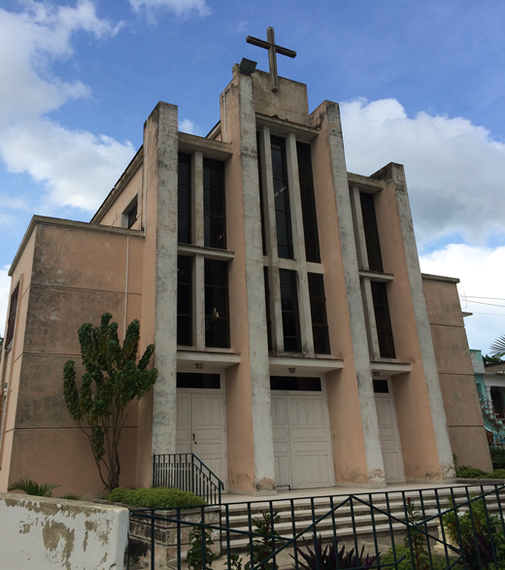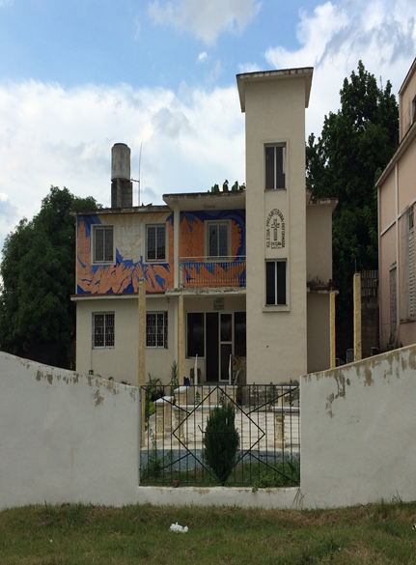

City: Located in the geographic center of the country in the province of Villa Clara. Population of ~ 250,000, 5th largest city in Cuba.

Economy: Sustained by a textile mill, marble quarry, and large tobacco factory. Home to most prestigious university outside of Havana.

Pastor: Edelberto Valdes; not his primary church.

Church: Organized in 1955; sanctuary built in 1957
Membership: ~ 70. There has been much uncertainty since their young pastor died in car accident five years ago and most recent pastor, Dalia, was asked to leave. Membership has been declining.

Church Projects/Activities:
- Sunday: Worship service and three Sunday school classes, though some uncertainty since no longer have full-time pastor.
- Prayer service and Bible study one day a week.
- Mission site: CANIP (2) (camp) is 10 km from the church in a farming community and receives much attention from the church. It is a Synod-wide camp. In addition to significant activities during the summer, there is a regular worship service and a project called “neighborhood school”. At the school there are educational courses, recreational activities, and a devotional.
- Laundry project for about 50 people, twice a week.
- Ecumenical center: Can house 20 people for courses, workshops, extension courses, etc.

Church Needs/Dreams:
- There may be an opportunity for a Living Waters for the World water purification system. Additional study is necessary.
- Feeding program for the elderly
- Music program for the children
- Recreation for the children
- A library

Partnerships/Friendships:
- First Presbyterian of Spartanburg, SC. Built the dormitory and meeting rooms. Bought the car for pastor who died in car accident.
- St. Andrew’s Presbyterian, Portland, OR.
- Several churches in Germany have had a relationship for 25 years.

Church Strengths:
- Located in a large provincial city, a mile from the central square.
- Located near the airport that mission teams will fly into.
- Ecumenical center can accommodate large groups, including mission teams from U.S.

Overnight Accommodations: The dorms are made up of four rooms, each with 2 to 5 bunk beds. Two rooms share a bath. Hot water available, though supply can be inconsistent. Food preparation and dining area are reasonable. Can accommodate up to 20 people.

TAGUASCO
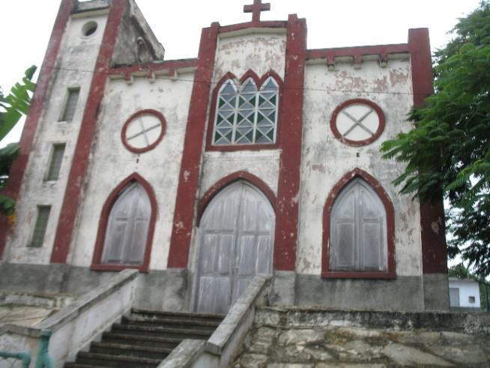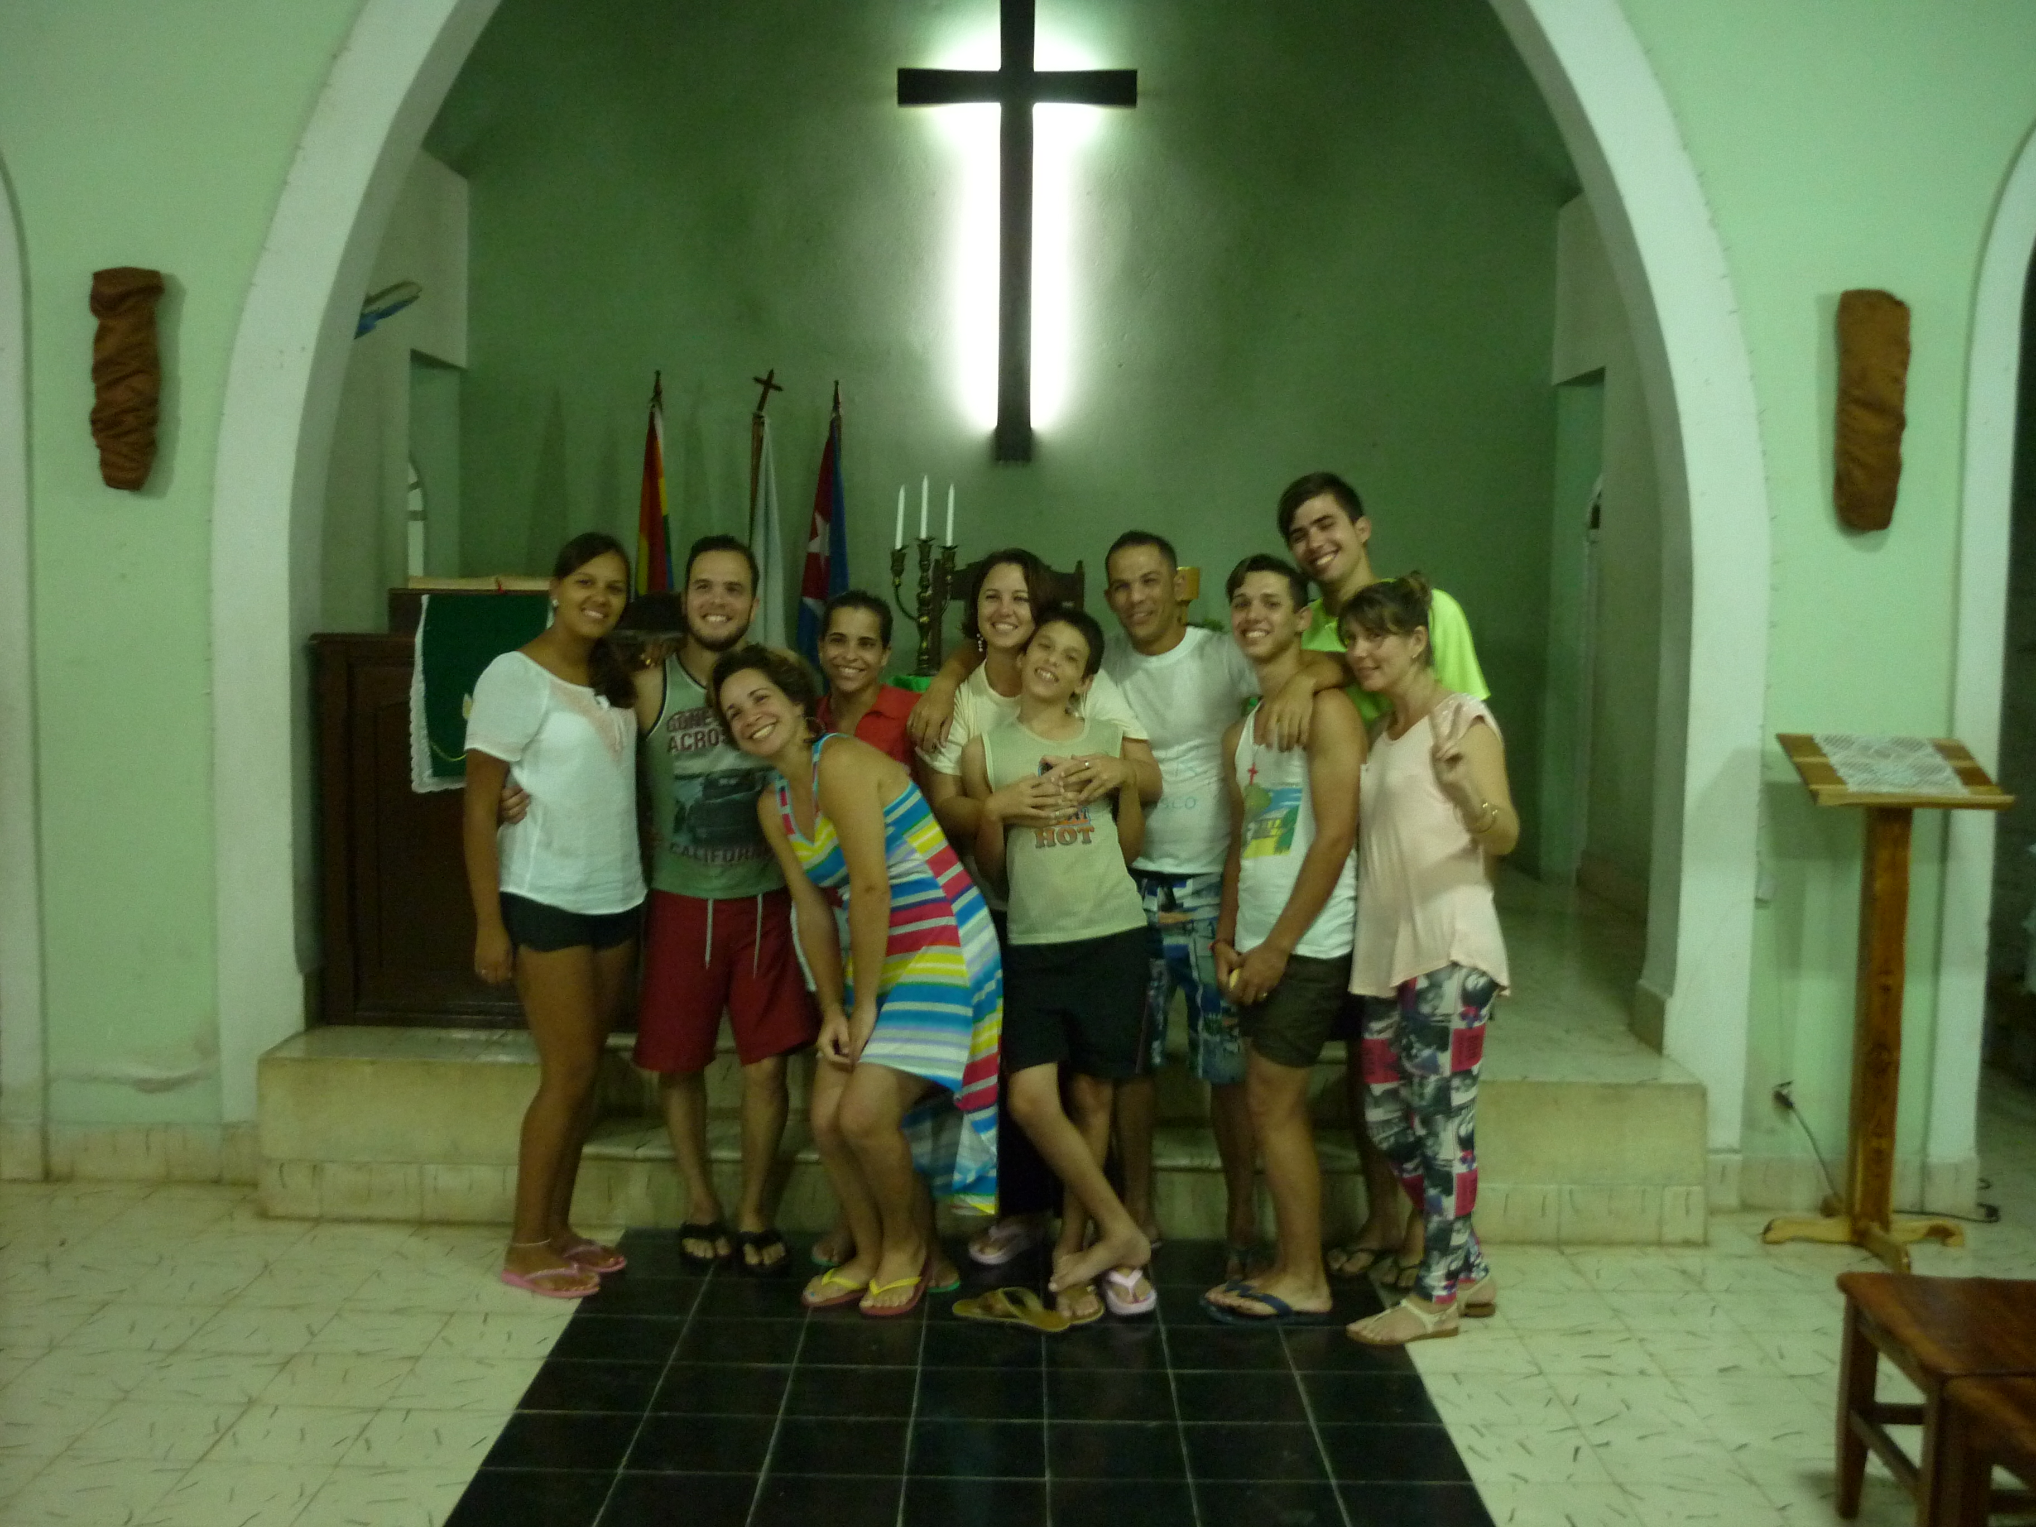

City: Located in province of Sancti Spiritus with a population of ~ 35,000.

Economy: Sustained by agriculture (tobacco, rice, sugarcane, and fruits) as well as a cement factory near town and a distillery.

Pastor: Liudmila Hernandez, though not full time. Various members of the congregation share the responsibility of organizing and coordinating the many activities of the church.

Church: Organized in 1932; sanctuary built in 1953. Membership ~40, but growing. This is a dynamic, growing, multi-generational church. Approximately 35 children attend Sunday School and Worship Service each week. In response to the historical discrimination of gays and lesbians by the Cuban government, the members of the congregation have reached out in love and welcomed members of this population into the church.

Church Projects/Activities:
- Sunday: Sunday morning worship service at 10:30 and Sunday School from 9:00 to 10:30 with five Sunday School classes; snacks and sometimes lunches for children.
- Prayers meetings during the week, with a devotional time on Friday
- Saturday night worship service
- Mission site: Las Margaritas (2), a poor neighborhood where participants meet in a home for a worship service. Also have a Sunday school for 20 to 30 children.
- Laundry ministry is offered on Wednesday and Friday. On Wednesdays the ministry is provided free of charge to the elderly of the community. On Fridays the laundry ministry is open to all in the community for a nominal charge that helps to cover soap for both Wednesdays and Fridays.
- Lunch project: Serves 20 people lunch every Tuesday and Thursday.
- Children’s education program
- They have formed a choir that participated in the Christmas festivities.
- Sewing ministry on Tuesdays and Thursdays r whenever needed. The group makes aprons, pillows, mats and repairs clothing when needed.
- The church has recently added a library that has a relationship with the municipal library. Books can be checked out. The library offers a literary tea twice a month where people are invited to come share poems and music.
- Counseling psychology is offered including how to deal with aging.
- A health program for the elderly includes an exercise class.
- And intergenerational choir has been formed that participated in the Christmas festivities.
- They have a mission church in Las Margaritas

Church Needs/Dreams:
- Sanctuary roof and walls are in need of repair. Baltimore Presbytery is providing some assistance for this. They would like to paint the walls.
- A means of transportation to pick up the elderly and children for church activities

Partnerships/Friendships:
- First & Franklin Presbyterian Church (Baltimore Presbytery)
- Highland Presbyterian Church (Tennessee)l. Limited financial support.
- First Presbyterian Church of New York City. Relationship in early stages.

Church Strengths:
- This is a visionary church. They deal extremely well with not having a full time pastor. They are very well organized with a strong sense of shared responsibility for the tasks of the church. Very intergenerational. There is a large group of youth and young adults who assist in worship and do service and mission work.
- Expanding laundry ministry is making the church more important to people in the community
- Music ministry – strong intergenerational choir experience at Christmas. Brought in numerous family members of children who are regular attendees.
- The church hires a horse and wagon to bring children t weekly Sunday School and worship
- Several years ago, this church realized there was a number of gay and lesbian individuals in the community and reached out in love. While they have no formal programs for this population, they are known as an open and affirming community to these persons who have been historically discriminated against in Cuba.

Overnight Accommodations: There is an upstairs apartment above the church kitchen which has its own kitchen, two bedrooms, and a full bathroom. One bedroom has a double bed and the other has two single beds. There is also another bedroom downstairs which has a full bathroom. This bedroom contains a double bed and a bunk bed. Both bathrooms have hot water.

